

Specification

for

SQLdm (Project Houston)

Jon Stelly

10/18/06



Proprietary and Confidential to BBS Technologies, Inc.

© 2006 BBS Technologies, Inc.; all rights reserved.

Revision history:
When? | Who? | What?

Table of Contents
1. Revision history: ii
2. Table of Contents iii
3. Requirements 1
3.1. Overview/Purpose 1
3.2. FAQ 1
3.3. Open Issues 1
4. Areas of Possible Failure 1
4.1. Network Points of Failure 2
4.1.1. Collection Service -> Management Service 2
4.1.2. Management Service -> Collection Service 2
4.1.3. Management Service -> Repository 3
4.1.4. Clients -> Management Service 3
4.2. Resource-Based Points of Failure 3
4.2.1. Processing Backlogs 3
4.2.2. 4
5. Internal Design 4
5.1. Architecture 4
5.2. Installation Issues 4
5.3. Schedule 4
5.3.1. Work Breakdown and Sizings 4
5.3.2. Areas of Risk 5
6. Quality Assurance Considerations 5
6.1.1. Overview 5
6.1.2. Developer-Created Unit Tests 5
7. Documentation Considerations 5
8. Bibliography 6

Requirements

Overview/Purpose
This document attempts to outline error handling and behavior for areas of the architecture of SQLdm that are possible points of failure. The goal in doing so is to ensure that the people making suggestions on design and implementation of features in the system are aware of the tradeoffs of code complexity, testing complexity, system reliability, and expected behavior of the system of choosing one solution over another.
Several failure points have obvious solutions or have already been addressed and those points will have our current plan for dealing with those errors in the doc along with pros / cons of that decision. Other failure points will be less obvious, and in those situations this document will attempt to present all reasonable options so we can all give informed input into deciding the correct course of action.

FAQ
This section should present a high level FAQ that is used to answer common questions from others as they read the spec and also that customers using the feature may ask. This should also provide a start for “He said, She said” documents for sales.

Open Issues

Areas of Possible Failure
Given the below system architecture, there are several areas in which failures could occur. The largest or most likely area of failure is networking between any 2 components of the system. Beyond the network area, it is possible for either the Management Service, Collection Service, Clients or the SQL Server used as our repository to have resource issues, be they memory issues, throughput or CPU issues, loss of power, etc…
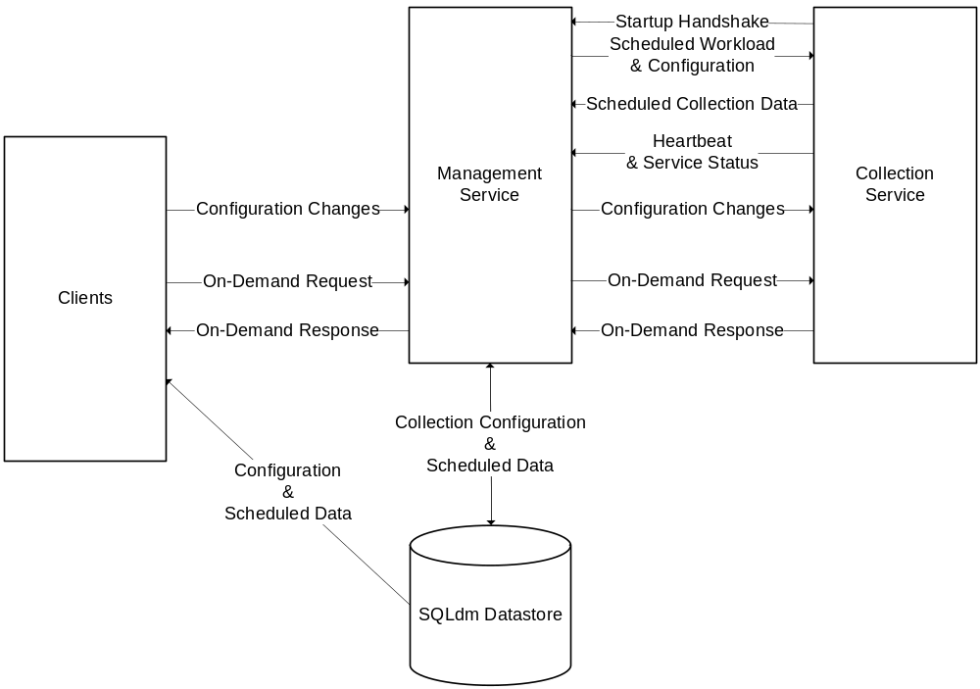

Network Points of Failure
These failures relate to connectivity between the different components of the SQLdm architecture.

Collection Service -> Management Service
The Collection Service communicates with the Management Service by means of establishing a session with the Management Service and attaching a session token with all future communications to the Management Service. The Management Service uses this session and heartbeats sent from the Collection Service to the Management Service as a means of monitoring the availability of the Collection Service.
In the event of the Collection Service losing its connection to the Management Service after a session is established, the Collection Service will enter into a disconnected mode where scheduled snapshot data is stored on the Collection Service while periodic attempts to re-open the session with the Management Service are made. Once the session is re-established the Collection Service will transmit the snapshots from its cache to the Management Service. No attempt will be made to save On-Demand snapshots while in disconnected mode.

Management Service -> Collection Service
The Management Service keeps track of Collection Service sessions and has a monitor process that wakes up periodically to make sure heartbeats are still being received for any open session. If a heartbeat is missed, a system event will be generated for possible notification to be sent to a system administrator. Part of the session info stored on the Management Service includes the endpoint on which the Management Service should connect to the Collection Service. The Management Service connects to the Collection Service to send configuration updates and On-Demand requests.
In the event that the Management Service cannot connect to the Collection Service, any On-Demand requests will fail and the nature of the failure will be reported back to the client that made the On-Demand request. In the event of configuration updates, if configuration updates are submitted and the Management Service is unable to send those updates to the Collection Service, the changes will be saved to the SQLdm Repository, and a value will be set on the Management Service in the Collection Service’s session information object that indicates an updated configuration. When the Collection Service reconnects and attempts to reopen its session after operating in disconnected mode, the Management Service will indicate to the Collection Service that configuration data has changed and that the Collection Service should reload its configuration/workload at the next available opportunity.
In this release that reconfiguration will probably involve retransmitting the entire workload for the Collection Service. In a future release this could be optimized and reduced to only transmitting the changed configuration values, but this failure case shouldn’t happen that often and I don’t believe it makes sense at this point to invest the time necessary to implement the more elegant solution.

Management Service -> Repository
The connection from the Management Service to the SQLdm Repository could fail for several reasons, either network connectivity, the SQL Server being taken down for maintenance, etc... In this case, the Management Service will refuse updates to configuration data from Clients and the Client should inform the user that their change was not saved and must be re-submitted when the Repository is available. The Management Service will also refuse Scheduled collection data from the Collection Service while the Repository is unavailable. The Collection Service should enter into disconnected mode at that point, caching snapshots and events as noted above. Clients should still be able to make On-Demand requests and the Management Service should be able to service those requests by forwarding to the Collection Service. With the repository down, Clients will be unable to retrieve most configuration information, such as the list of Monitored Servers, Thresholds, historical snapshots and events, etc… [Trent, you want to go into detail here about expected client behavior?]

Clients -> Management Service
The Management Service is the main contact point for Clients. If the Client is unable to communicate with the Management Service, at most they could display historical data, but with so much data missing from the Management Service, it might make more sense to just display that the Client is unable to connect and require the Management Service to be available to use a client.

Resource-Based Points of Failure
These failures relate to resource usage of a given component in relation to the total available resources on the machine on which it runs. Also noted here are loss of power types of failures where the service could abnormally terminate in the middle of any given operation or request.

Processing Backlogs
There are several points in both services where data must be processed, and if more data arrives than is able to be processed, a backlog of data could accumulate increasing memory usage until causing OutOfMemory exceptions if not properly handled. Notification Processing is one possible area this could happen. Scheduled Collection is another if a Collection Service is running on a machine that is unable to keep up with the amount of servers or frequency with which it must monitor them. Both of these points are areas we will likely collect system metrics so administrators can set up notifications for when either backlog begins to threaten system availability.

Abnormal Termination
Loss of power or other forms of abnormal process termination could happen at any time in the middle of any piece of code. To ensure that all data remains in a sane state, changes to our repository will be transacted so they can be rolled back if they aren’t able to complete in their entirety.
Since changes to the repository are transacted, in the event of a remote service terminating in the middle of a call, the calling service or process should assume that none of the requested work was accomplished and should either retry the call at the next opportunity or take whatever action is appropriate depending on the nature of the request.

Internal Design

Architecture
An overview of the architecture behind this feature – how it works, components, communication between components etc

Installation Issues
Insert changes for installation – new files to be dropped, new configuration screens etc. Think about the initial install and upgrade cases.

Schedule

Work Breakdown and Sizings
Insert areas that put the implementation or schedule at risk – Assumptions made in design, new areas that have a learning curve etc. Break the project into logical components and add time for design, coding, integration, unit testing. These estimates should not take into account outside forces like maintenance work. These will be applied in building the overall project schedule. A general rule of thumb is to break any unit of work greater then 1 week into smaller pieces to ensure accuracy and to allow measurement of progress during the project.
Component | Who | Sizing
R&D
Code Piece #1
Code Piece #2
Porting
Unit and Integration Testing
Total

Areas of Risk
There are many types of risks. For example, a section might describe
- Areas with big learning curve
- Design assumptions that still need to be proven
- a technical hurdle that needs to be overcome.
- An area which has many unknowns
- Outcomes of other plans/implementations which could affect the deliverability of this feature.
Where possible, each section should explain the risk, quantify the risk, enumerate possible actions to address the risk, and recommend the action that is appropriate.

Quality Assurance Considerations

Overview
Insert explanations for QA considerations that are not apparent from the rest of the specification. Include things like tests on platforms that you want run in greater width then a developer can easily do or which tests you would want as an acceptance test each time a release goes out the door.
This section should identify all the testing activity that should be performed to verify the project has:
- Satisfied the completion criteria
- Works consistently with the existing components or works at least as well as the component being replaced
- No other components have lost functionality or no longer work
- Meets the standards as defined and approved by this document
- Identifies all the edit rules for each data element in the process

Developer-Created Unit Tests
Automated, Developer-Created Unit Tests which will be Created (and Passed to QA)
Developer Tests which will be Manually Performed

Documentation Considerations

Bibliography

